USDA-FOREST SERVICE FS-2500-8 (6/06)

Date of Report: 09/08/2023

BURNED-AREA REPORT
(Reference FSH 2509.13)

PART I - TYPE OF REQUEST

A. Type of Report

[ ] 1. Funding request for estimated emergency stabilization funds
[ ] 2. Accomplishment Report
[X] 3. No Treatment Recommendation

B. Type of Action

[X] 1. Initial Request (Best estimate of funds needed to complete eligible stabilization measures)

[ ] 2. Interim Report
[ ] Updating the initial funding request based on more accurate site data or design analysis
[ ] Status of accomplishments to date

[ ] 3. Final Report (Following completion of work)

PART II - BURNED-AREA DESCRIPTION

A. Fire Name: East Fork

C. State: Montana D. County: Flathead and Lincoln

E. Region: Northern (1) F. Forest: Kootenai and Flathead

G. District: Tally Lake and Ksanka H. Fire Incident Job Code: N/A

I. Date Fire Started: 7/30/2023 J. Date Fire Contained: Not contained

K. Suppression Cost: $XXXX

L. Fire Suppression Damages Repaired with Suppression Funds
1. Fireline waterbarred (miles): Most fireline on existing roads
2. Fireline seeded (miles):
3. Other (identify):

M. Watershed Numbers:

N. Total Acres Burned:
NFS Acres (approx. 5,221) Other Federal () State () Private ()

O. VegetationTypes: Douglas fir, Engelmann spruce, larch, sub-alpine fir, riparian

P. Dominant Soils:

Q. Geologic Types:

R. Miles of Stream Channels by Order or Class:

Stream miles by order within perimeter.
Stream Order | Length (Miles)
1
2
3
4
5
Grand Total

S. Transportation System

Trails: miles Roads:___ miles

PART III - WATERSHED CONDITION

A. Burn Severity (acres): 2,019 (unburned); 1,548 (low); 1,320 (moderate); 334 (high)

B. Water-Repellent Soil (acres): High severity and moderate portions have varying degrees of water repellency, as determined by drip test.

C. Soil Erosion Hazard Rating (acres):
XXXX (low) XXXX (moderate) XXXX (high)

D. Erosion Potential: 0.8 tons/acre

E. Sediment Potential: 0.5 tons/acre

PART IV - HYDROLOGIC DESIGN FACTORS

A. Estimated Vegetative Recovery Period, (years): 3

B. Design Chance of Success, (percent): 80

C. Equivalent Design Recurrence Interval, (years): 5

D. Design Storm Duration, (hours): 6 hour

E. Design Storm Magnitude, (inches): 1.5 inches

F. Design Flow, (cubic feet / second/ square mile): 5 cfs/mi²

G. Estimated Reduction in Infiltration, (percent): 30

H. Adjusted Design Flow, (cfs per square mile): 70 cfs/mi²

PART V - SUMMARY OF ANALYSIS

A. Describe Critical Values/Resources and Threats:

Summary of Potential Watershed Response

The East Fork Fire burned roughly 5,221 acres in the headwaters of Martin Creek and Sunday Creek on the Flathead and Kootenai National Forests, respectively. The BARC map (Figure 1) was not field verified, but extensive experience on the forest has determined that preliminary imagery slightly overpredicts actual severity.

Watershed response is expected to be low with storm recurrence intervals of 5 years or less. The burned area has experienced low intensity, long duration moisture in the past two weeks. This type of rain is very common in the fall which increases needle-cast and speeds soil recovery. Most burned areas are in the headwaters of the watersheds with small catchment area. Several streams are shown on the NHD stream layer but are not present on the ground.

Values at Risk:

The risk matrix below was used to evaluate the Risk Level for each value identified during Assessment (Exhibit 2 of Interim Directive No.: 2520-2010-1). Proposed treatments and their associated risk levels are discussed below in the following categories: Life, Property, and Natural Resources.

Probability of Damage or Loss | Magnitude of Consequences
 | Major | Moderate | Minor
 | RISK
Very Likely | Very High | Very High | Low
Likely | Very High | High | Low
Possible | High | Intermediate | Low
Unlikely | Intermediate | Low | Very Low

Human Life and Safety, Property, and Natural Resources

The majority of roads are Maintenance Level 1-4. Post-fire runoff is expected to be minimal due to lower elevation, low burn severity, and mosic burn patterns. Road impacts are expected to be minimal. Post-fire impacts to water quality are expected to minimal as well. The potential for weed spread will be addressed through the suppression repair and the BAR program.

Risk Assessment – Threats to life, safety, property, and natural resources

Probablity of Damage or Loss: Unlikely

Magnitude of Consequence: Minor

Risk Level: Very Low

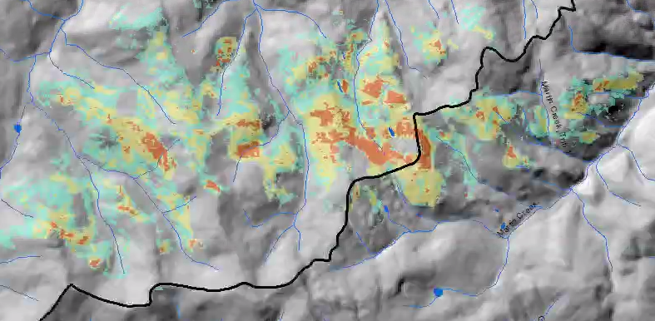
Figure 1. East Fork BARC map.

B. Emergency Treatment Objectives:

None

C. Probability of Completing Treatment Prior to Damaging Storm or Event:

Land % Channel % Roads/Trails % Protection/Safety %

D. Probability of Treatment Success

 | Years after Treatment
 | 1 | 2 | 3
Land
Channel
Roads/Trails
Protection/Safety

E. Cost of No-Action (Including Loss): $

F. Cost of Selected Alternative (Including Loss): $

G. Skills Represented on Burned-Area Survey Team:

[X] Hydrology [X] Soils [ ] Geology [ ] Range
[] Forestry [ ] Wildlife [ ] Fire Mgmt. [X] Engineering
[] Recreation [ ] Ecology [X] Botany [ ] Archaeology
[X] Fisheries [ ] Research [ ] Landscape Arch [ ] GIS

Team Leader: C. Neal Kendall
Email: craig.kendall@usda.gov Phone: 406-897-3180

H. Treatment Narrative:

I. Monitoring Narrative:

PART VII - APPROVALS

1. /s/ ________________
Forest Supervisor Date

2. /s/ _________________
Regional Forester Date

